SYMPTOM & MEDICATION JOURNAL - PROJECT
REPORT

Submitted by: - Somya Singh

Registration no.: - 26BCE11150
Course: - Introduction to Problem Solving And Programming
Platform: - VITyarthi - Build Your Own Project

Introduction: -
Symptom & Medication Journal is a digital health tracking tool that aims to replace
manual paper-based medical logs. This implementation uses Python's Tkinter
library to provide a graphical interface (vs command-line menu) and live journal
list. The application allows a user to record medication intake and symptom
occurrence with exact timestamps as a structured way to track their personal health
history which may help in conversations with a healthcare provider.

Problem Statement: -
Management of chronic conditions(e.g., migraines, arthritis, allergies) is heavily
dependent on human memory which is subjective and error-prone. Patients often
cannot answer questions which are specific and clinically-relevant to a doctor(e.g.,
"How many times did you take this painkiller last month?" or "How much time
elapsed between the start of a symptom and the medicine taking effect?") Without
accurate and easy-to-review data, measuring how effective a treatment is becomes
challenging.

Functional Requirements: -
Core capabilities provided by the system include:
- Item Management: Users can add a new medication or symptom to their tracking list, choosing its category (Medication/Symptom) from a dropdown menu.
- Event Logging: Users can select an item from the journal list and log an occurrence for it; the system automatically captures the current timestamp.
- Live Summary View: Same journal list always shows total occurrence count and latest timestamp for every tracked item. No separate menu required.
- Item Removal: Users can delete an item they no longer want to track directly from the list.
- Input Validation: - System normalizes names via .strip().title() to treat "Advil" and "advil" as same entry, and blocks empty names / missing selection with appropriate warning pop-ups.
- Non-Functional Requirements: -
- Usability: GUI uses labeled fields, a dropdown for category selection, and click-based list selection. No need to remember menu numbers or item indexes.
- Reliability: System does not crash on invalid input(e.g., logging an event with no item selected); it checks selections before action and displays a warning instead.
- Data Integrity: Timestamps are system-generated and cannot be typed in or falsified by the user.
- Maintainability: Interface code (create_widgets) is separated from the logic (add_item, log_occurrence, delete_item, refresh_list); each can be maintained independently.

System Architecture: -
The application uses a simple layered architecture:
- Presentation Layer (GUI): Tkinter-based - An entry field, a dropdown for category, a journal Listbox, and Add/Log/Delete buttons.
- Logic Layer: Python functions that add new items, increment counts, get timestamps, and remove items from the tracked list.
- Data Layer: List of dictionaries in memory for the session; one dictionary for each tracked item (name, category, count, last_logged).

Design Decisions & Rationale: -
- Language Choice (Python): Chosen for its readability and its built-in Tkinter library, that needs no extra installation for a desktop GUI.
- GUI over CLI: Original command-line menu was replaced with GUI to be user-friendly to those who are not comfortable typing menu numbers.
- Listbox for the Journal: Single Listbox is used to double as the item list and summary view; avoids a separate "View Summary" screen.
- In-Memory List: A list of dictionaries is stored in memory as the data store, not a database; allows keeping logic close to the original console version for easier maintainability.
- Implementation Details: -
The core logic relies on Python's datetime module for temporal tracking.
- Input Sanitization: .strip().title() method chain is applied to every name entry to prevent extra spaces and inconsistent capitalization causing duplicate-looking entries.
- Selection-Based Actions: Logging and deleting both use the selected row's position in the Listbox to locate the matching dictionary in the data list.
- exportselection=False: Set on the journal Listbox to ensure its selection is predictable and not accidentally cleared by other interactions.
- Screenshots / Results: -
- Adding a new item with its name and category
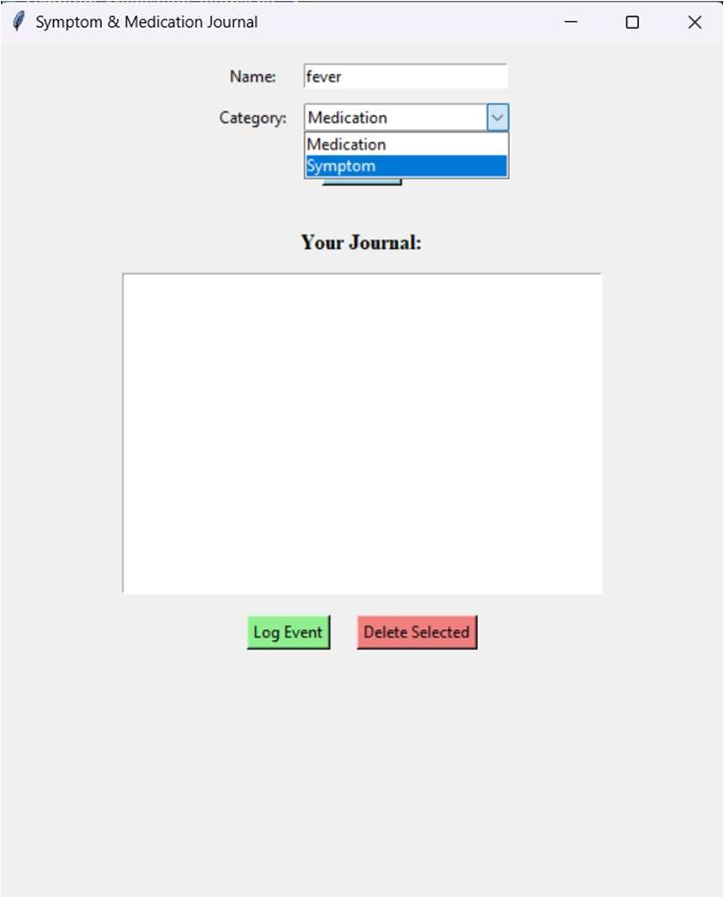
- Logging an event for a selected item
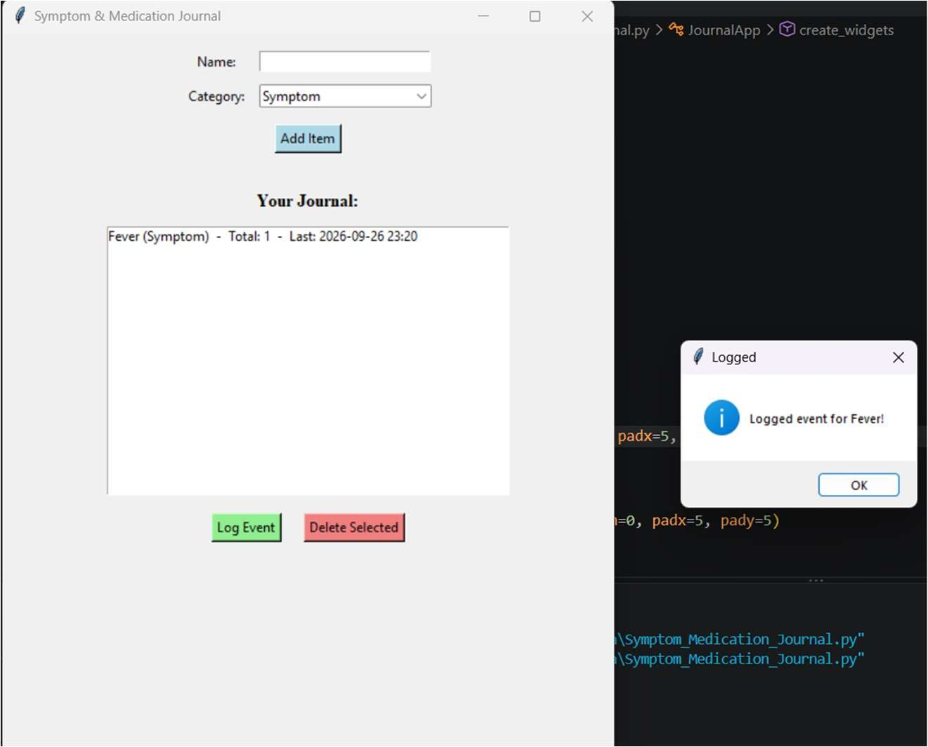
- Viewing the live journal with counts and last-logged times
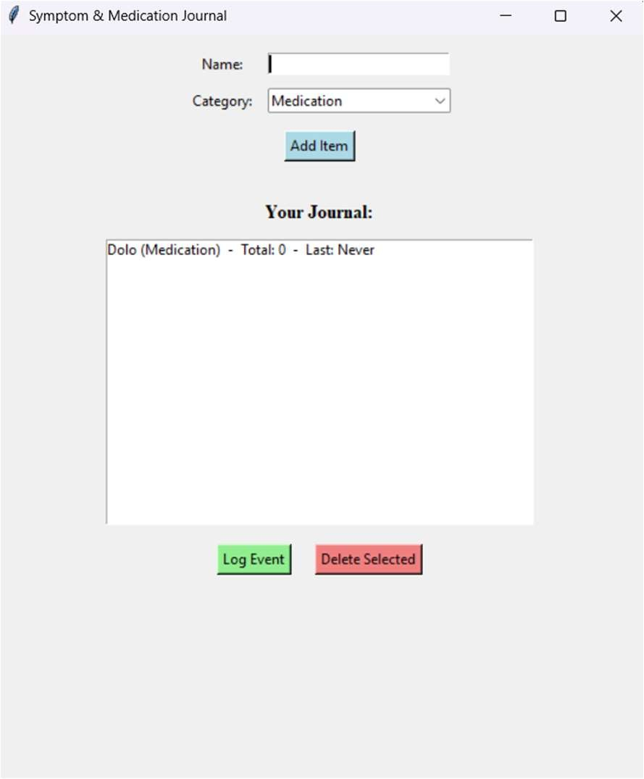

Testing Approach
- Unit Testing: Simulated adding, logging, and deleting items to ensure each action only updates the correct entry in the data list.
- Boundary Testing: Simulated adding, logging, and deleting items to ensure each action updates only the correct entry in the data list.
- Format Testing: Verified that timestamps are recorded and displayed correctly to the minute after logging an event.

Challenges Faced: -
- Rebuilding the console menu's three actions (Add, Log, View Summary) as GUI equivalents, without losing any of the original functionality.
- Matching a clicked row in the Listbox back to the correct dictionary in the data list, since the Listbox only stores displayed text, not the underlying record.
- Deciding how to represent "View Summary" in a GUI - solved by keeping the journal list always up to date, not requiring a separate button.

Learnings & Key Takeaways: -
- Learned how to translate a console menu's logic into GUI event handlers that respond to button clicks.
- Learned how to match Tkinter's Listbox selection to a parallel Python data structure by index.
- Reinforced the importance of automatic timestamps for generating reliable and trustworthy health data.

Future Enhancements: -
- Data Persistence: Save the journal to a file (CSV or SQLite) so that entries are not lost when the program closes.
- Visualizations: Use Matplotlib to plot symptom frequency and medication timing trends over time.
- AI Analysis: Use correlation or regression techniques (e.g., Pandas and Scikit-learn) to suggest associations between medications and symptom relief.
- References: -
- Python 3 Documentation: docs.python.org
- Tkinter Reference: https://tkdocs.com/
- "Automate the Boring Stuff with Python" by Al Sweigart
- VITyarthi Project Guidelines

